**Abstract:**

Seagate.co a computer storage device manufacturing company has planned to open up a new branch out in Cyberjaya and restructure the existing infrastructure in Penang. The new infrastructure will comprise of a new building in Cyberjaya and remodeling of the first building in Penang with two floors each. Our team is assigned for overall network designing inside the office premises. Each and every floor is made for appropriate network design for the new infrastructure.

The Configuration of a proper, working reliable network consisting of essential equipment for the staff working at the company is the objective of this project. All the logical networking diagram is done via *Cisco Packet Tracer* software.

**Acknowledgement:**

We would like to thank each and every one who assisted us for this assignment. Our team would also love to express our sincere gratefulness to our subject teacher, Mr. Yuvraj Sharma. His incredible support and daily motivation helped us a lot throughout the completion of this assignment. Likewise, we’d also like to commend each and every one of our group members for actively participating and cooperating during the assignment.

Contents

Floor Design: 5

Ground Floor (Safal Acharya NPI000170) 5

First Floor (Sajag Shrestha NPI000172) 7

Branch Office (Seagate.co) Cyberjaya, Malaysia 9

Ground Floor (Rangin Basnet NPI000167) 9

First Floor (Riden Paudel NPI000168) 10

Topology: 11

Star Topology: 11

IP Addressing and Subnetting Plan: 12

Networking and Host Devices: 15

Router 15

Switch 17

Personal Computer (PC) 18

Closed-Circuit Television (CCTV) 19

Printer 20

Telephone 21

Server 22

Wireless Access Point 23

Description of the Network configuration 25

Second floor of branch office (Cyberjaya) 26

Static IP of webcam (IOT) 27

Static IP of Servers 34

Static IP of Printer 37

Static IP of Access Point 41

Dynamic Host Configuration Protocol (DHCP) [Safal Acharya NPI000170]: 42

Cisco Telephony [Safal Acharya NPI000170]: 44

Serial Configuration [Rangin Basnet NPI000167]: 47

Router RIP configuration [Riden Paudel NPI000168]: 48

Dial Peer Configuration [Sajag Shrestha NPI000172] 49

Switchport Voice VLAN [Sajag Shrestha NPI000172] 50

*Referencing:* 51

# Floor Design:

Head Office (Seagate.co) Penang, Malaysia

We have dsigned all the floors using Microsoft visio.

# Ground Floor (Safal Acharya NPI000170)



fig .0: ground floor head office (Seagate.co)

It is the ground floor of the head office of the company. It is located in Penang, Malaysia. It consists of reception area, waiting room, Cafeteria, Security and Delivery room, CEO room, CTO room, Finance and sales room, administrative office. Each room with the corridor area are continuously monitored with the help of high-quality CCTV. The main entrance of the building is joined with the waiting room where receptionist is present to assist the visitors. Receptionist use a single PC to keep record of the visitors. A and line phone is connected on the receptionist table. Waiting room has pleasant sitting arrangement with Wi-Fi access point and water dispenser. For security reasons it is under continuous surveillance with high-quality CCTV. Long corridor instantly runs through the centre of the floor which joins all other rooms on the floor and ends with the upstairs at the end.

Cafeteria is along with the waiting room which is in easy access to all the staffs and the visitors too. A common rest room is at the side of corridor where it starts.

CEO room is at the side of waiting room with attached restroom. There is a PC, landline phone and a printer.

Chief technical officers (CTO) room and Finance and Sales room are at the middle way of the corridor. There are two PC and a landline in the finance room where as CTO room has one PC and landline.

Administrative room and security and delivery room are at the end of the ground floor on either side of the corridor. Each room consist of a PC and landline.

# First Floor (Sajag Shrestha NPI000172)



fig .1: first floor

First floor consists of seven rooms with two conference room, a Server room, a research and design room, Manufacturing room, a technical assistant room and a staff rest area. A long corridor in between the floor joins them and ends with two male and female rest rooms at the corner. The main conference room consist of router for good network strength and a display projector. Each room are secured with high quality surveillance camera. No staff has to worry about their belongings inside the office premises. CCTV are also most for the safety of office assets and equipment. Server room consist of 10 servers. The floor consists of two routers and Wi-Fi access points. Main conference room is used for general meeting between all the staffs or with costumers and staffs while other conference room is used for small meetings conducted within departments.

# Branch Office (Seagate.co) Cyberjaya, Malaysia

# Ground Floor (Rangin Basnet NPI000167)



fig 2: Ground floor (Branch office Cyberjaya)

Seagate.co branch office in Cyberjaya has two floors with multiple rooms. Main entrance of the ground floor opens to reception and waiting room with staircase which leads to first floor of the building. All the rooms along with the corridors and waiting room are under surveillance of CCTV. It ensures the security of staffs, visitors, their belongings and office assets. All the offices are well furnished and designed for staff’s comfort. Sitting arrangements for costumers and visitors are also specially considered for their best comfort. Costumers are not let bored waiting for their turn. Strong Wi-Fi access point in waiting room allows customers to be engaged. Delivery department is on the ground floor and near to the waiting room so that costumer can have quick access. Rest room at the end of corridor is easily visible and accessible for everyone.

# First Floor (Riden Paudel NPI000168)



fig 2.1:First floor(Branch office (Cyberjaya)

First floor of Branch Office (Cyberjaya) has small waiting room with a table two sofa with air conditioner. The floor comprises two conference room, a high dedicated server room, in the middle. Manufacturing room is at the end of the floor. Staff rest room with a snooker board and table tennis board refreshes and reenergizes the office staffs. Three switch are used in this floor and end devices are joined with star topology. Each room are monitored with high quality CCTV.

# Topology:

We have used star topology inside the building permises.

# Star Topology:

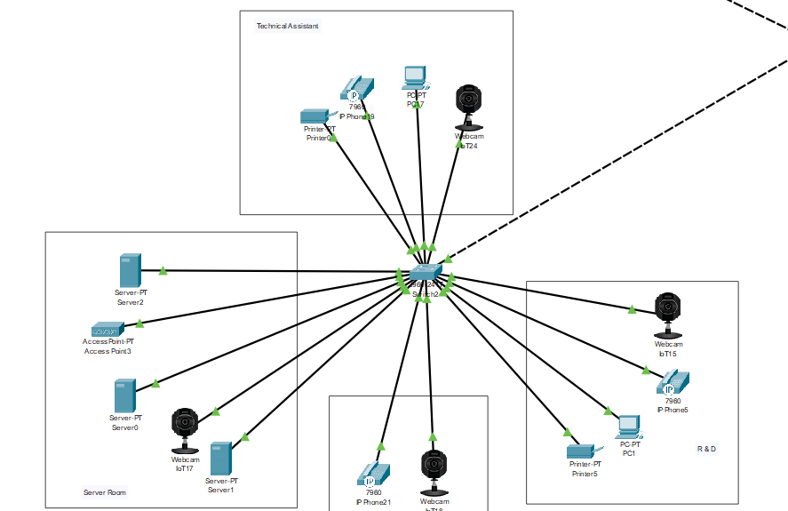

fig :showing network using star topology

Star topology is one of the generally usd topology in networking. Here all the end devices ie Laptops pcs smartphones printer etc are connected to the common networking device switch with the cable which provides internet to all the devices. One of the main advantage of using star topology over other is simplicity in its management and maintainance. Since each end device has separate connection so failures affects a single device and is easy to detect and maintain. Here failure of connection in one device doesn’t affect entire connection. Thus it has higher reliability compared other topologies in long run. Here no device has direct connection, instead a central networking device is used to connect them. The topology is designed in the form of star which includes one routers and 7 switches in each building.

# IP Addressing and Subnetting Plan:

**Head Office, Penang Ground Floor:**

**Switch 4:**

**Reception and Waiting room**

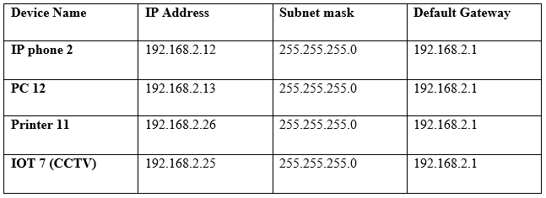

**CEO room**

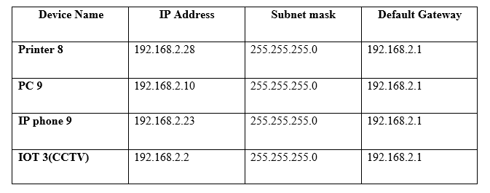

**Administration Room:**

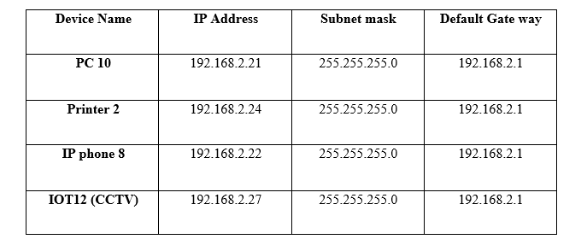

**Cafeteria:**

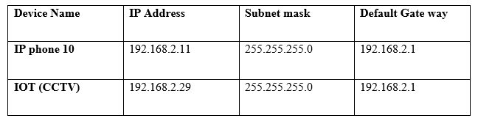

**Switch 3:**

**Finance and Sales:**

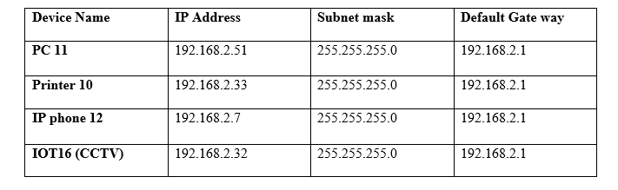

**CTO Office:**

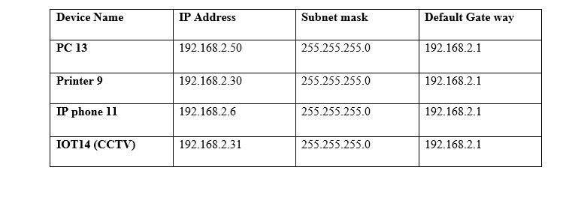

**Security and Delivery Department:**

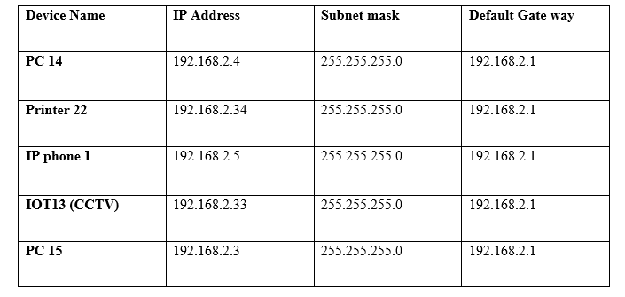

# Networking and Host Devices:

# Router

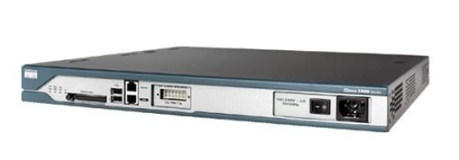

fig :Router

A router is a networking device that joins number of switches connected to several end devices to form a larger network. These switches can be inside a small area or may be apart in distant location. It works on network layer of the OSI model. It manages incoming and outgoing of data. It provides access to the internet for multiple devices within its network. It searches for the shortest and best possible route for data packets to move to the destinated Ip address. It stores Ip address in the routing table.

**Technical Specification:**

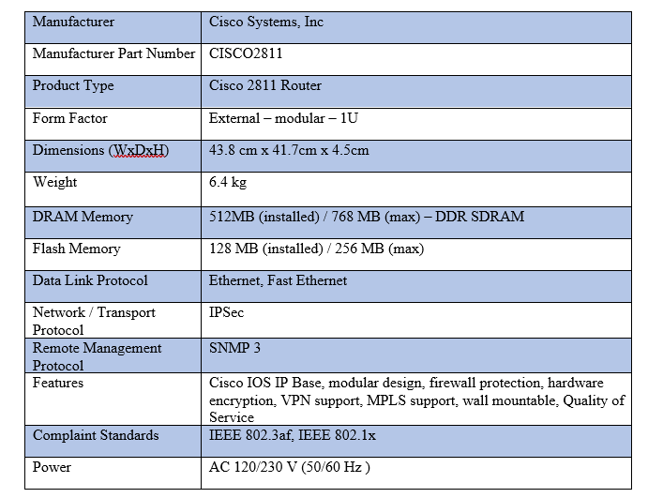

# Switch

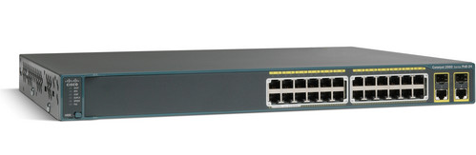

fig :Switch

The main and primary function of the switch is to connect end devices such as laptops, printers, desktops etc. in the network. It works on data link layer of the OSI model. It stores MAC address in the look up table which helps to know the source and the destination address. It is used in LAN.

**Technical Specification:**

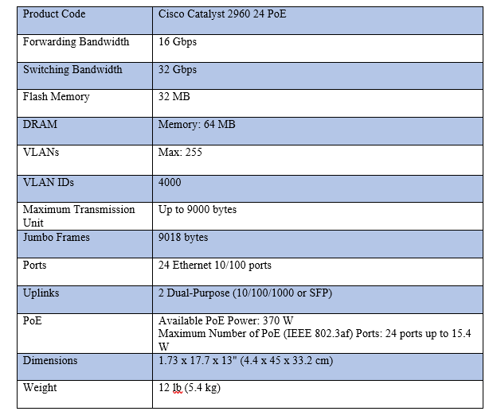

# Personal Computer (PC)

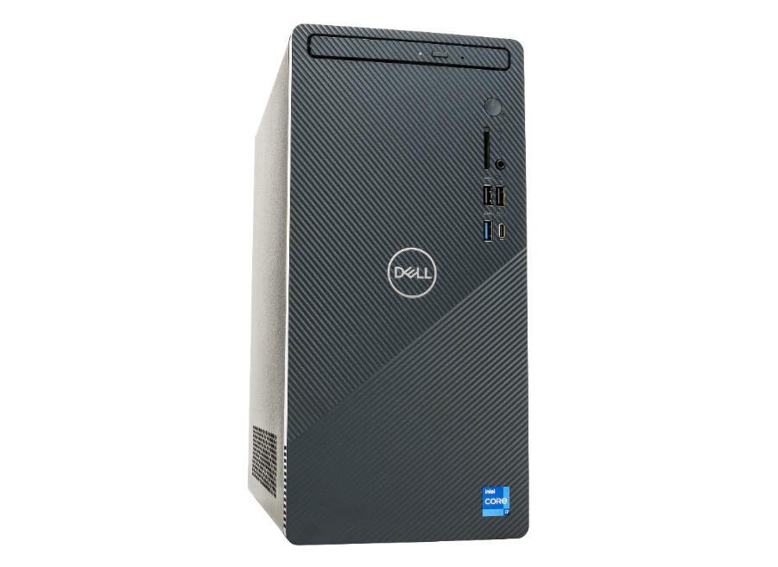

fig :PC

**A personal computer is a digital computer intended to be used by one and only one person at a time. It is a multi-purpose microcomputer which has the size, capabilities, and price in a way which makes it feasible for individual/personal use.**

**Technical Specification:**

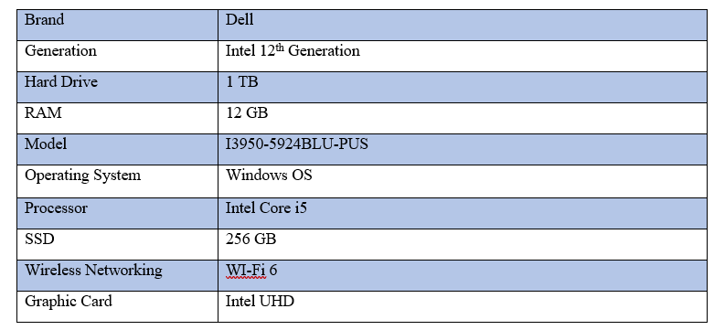

# Closed-Circuit Television (CCTV)

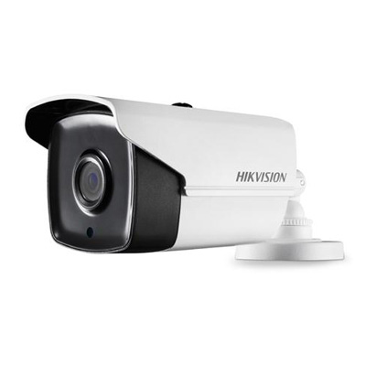

fig Webcam

Closed-Circuit television (CCTV) is a TV system where signals aren’t publicly circulated but are instead monitored, mainly for surveillances and security purposes to prevent theft, robbery and shoplifting, etc. CCTV should be strategically placed. The areas where it has maximum area coverage can be suitable for some location whereas it is intensely focused on areas having higher sensitivity or area prone to criminal activities . Because of such technology the surveillance has seen significant growth preventing host of crimes throughout the world.

**Technical Specification:**

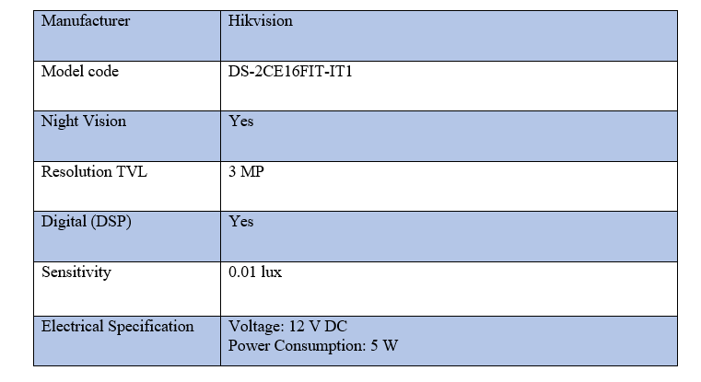

# Printer

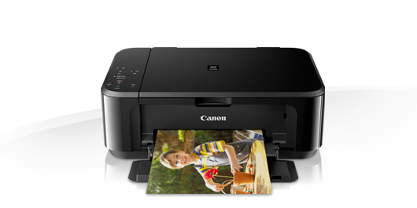

fig :Printer

Printers are most common output device which gives us hard copy output. It is most commonly present in any kind of offices from small to big. Copying of data in mass numbers is possible with printers. The most common and used connection types for printers are via USB cable or Wi-Fi, both wired and wireless respectively.

**Technical Specification:**

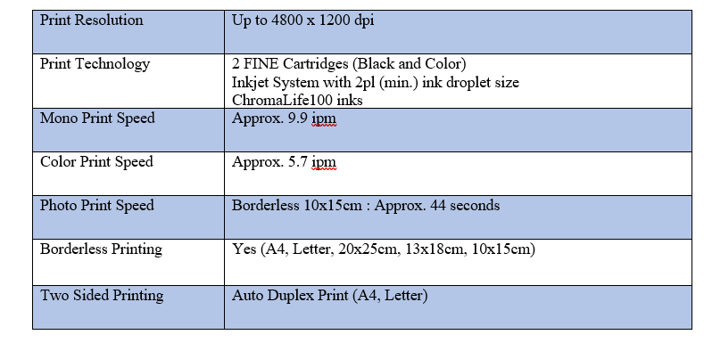

# Telephone

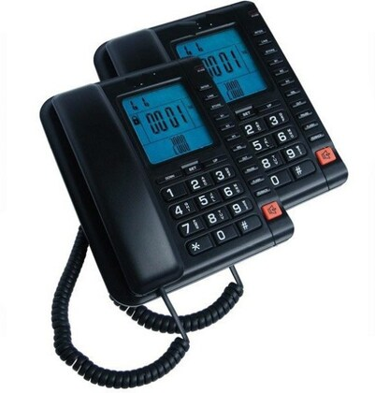

fig :telephone

A Telephone is a telecommuting device which is used to converse between two or more users from afar for clear and easy communication. A telephone converts sound i.e., end users voice into electrical signals to be carried out through cables and any other communication channels from one telephone to another to regenerate the sounds for the receiver.

**Technical Specification:**

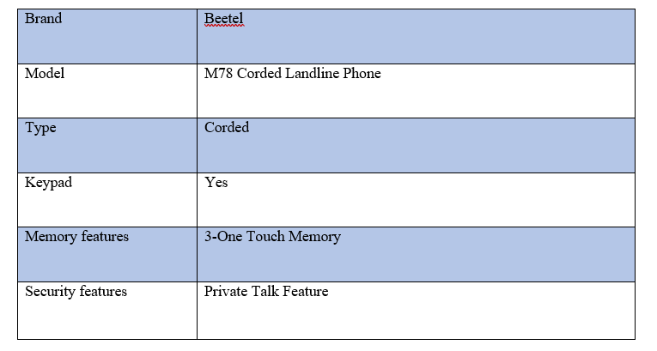

# Server

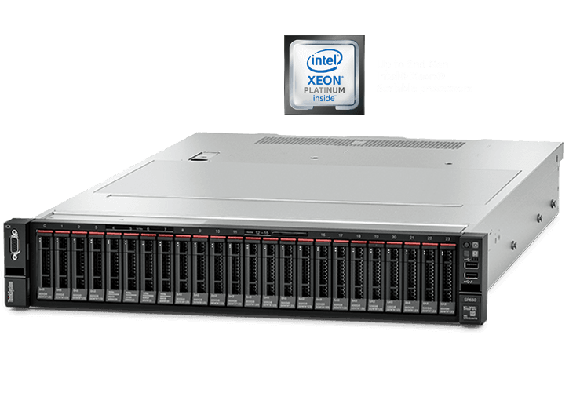

fig :Server

A server is a system which delivers various data, resources, services, or programs to other clients over a network. Simply they are the computers that facilities the need or quires of other computer or any end devices. For a server to properly function, a device should be configured to take note to the requests from the clients on a network connection.

**Technical Description:**

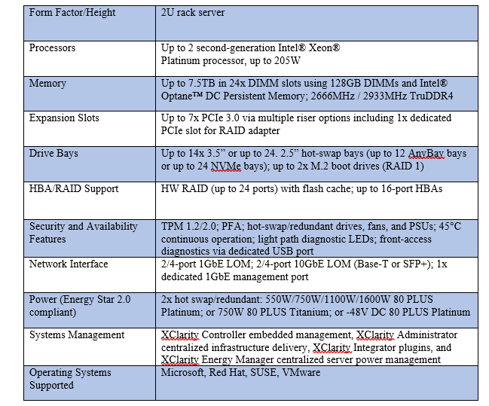

# Wireless Access Point

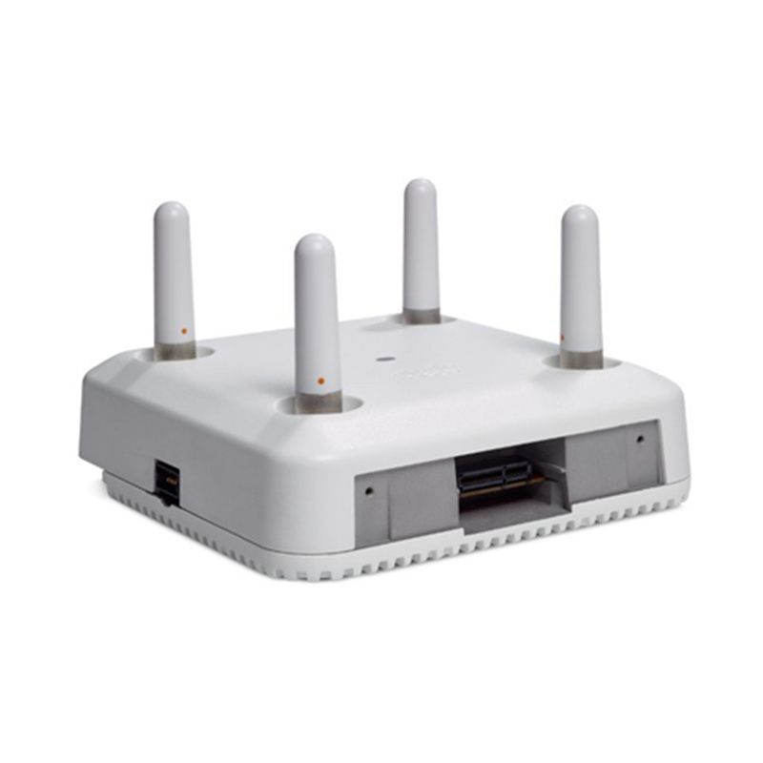

fig :Access point

Wireless Access Point are simply radio transmitters that represents a node, pretty much like a computer, on a Local Area Network (LAN). It is a device which allows various types of wireless networking cards that connects without any use of cables i.e., wireless, for connecting to LAN’s and accessing resources, including the Internet. Most importantly it takes your Wi-Fi outside from your room. It improves wireless network, its range and speed.

**Technical Specifications:**

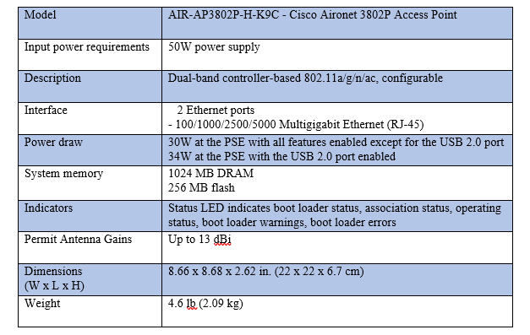

# Description of the Network configuration

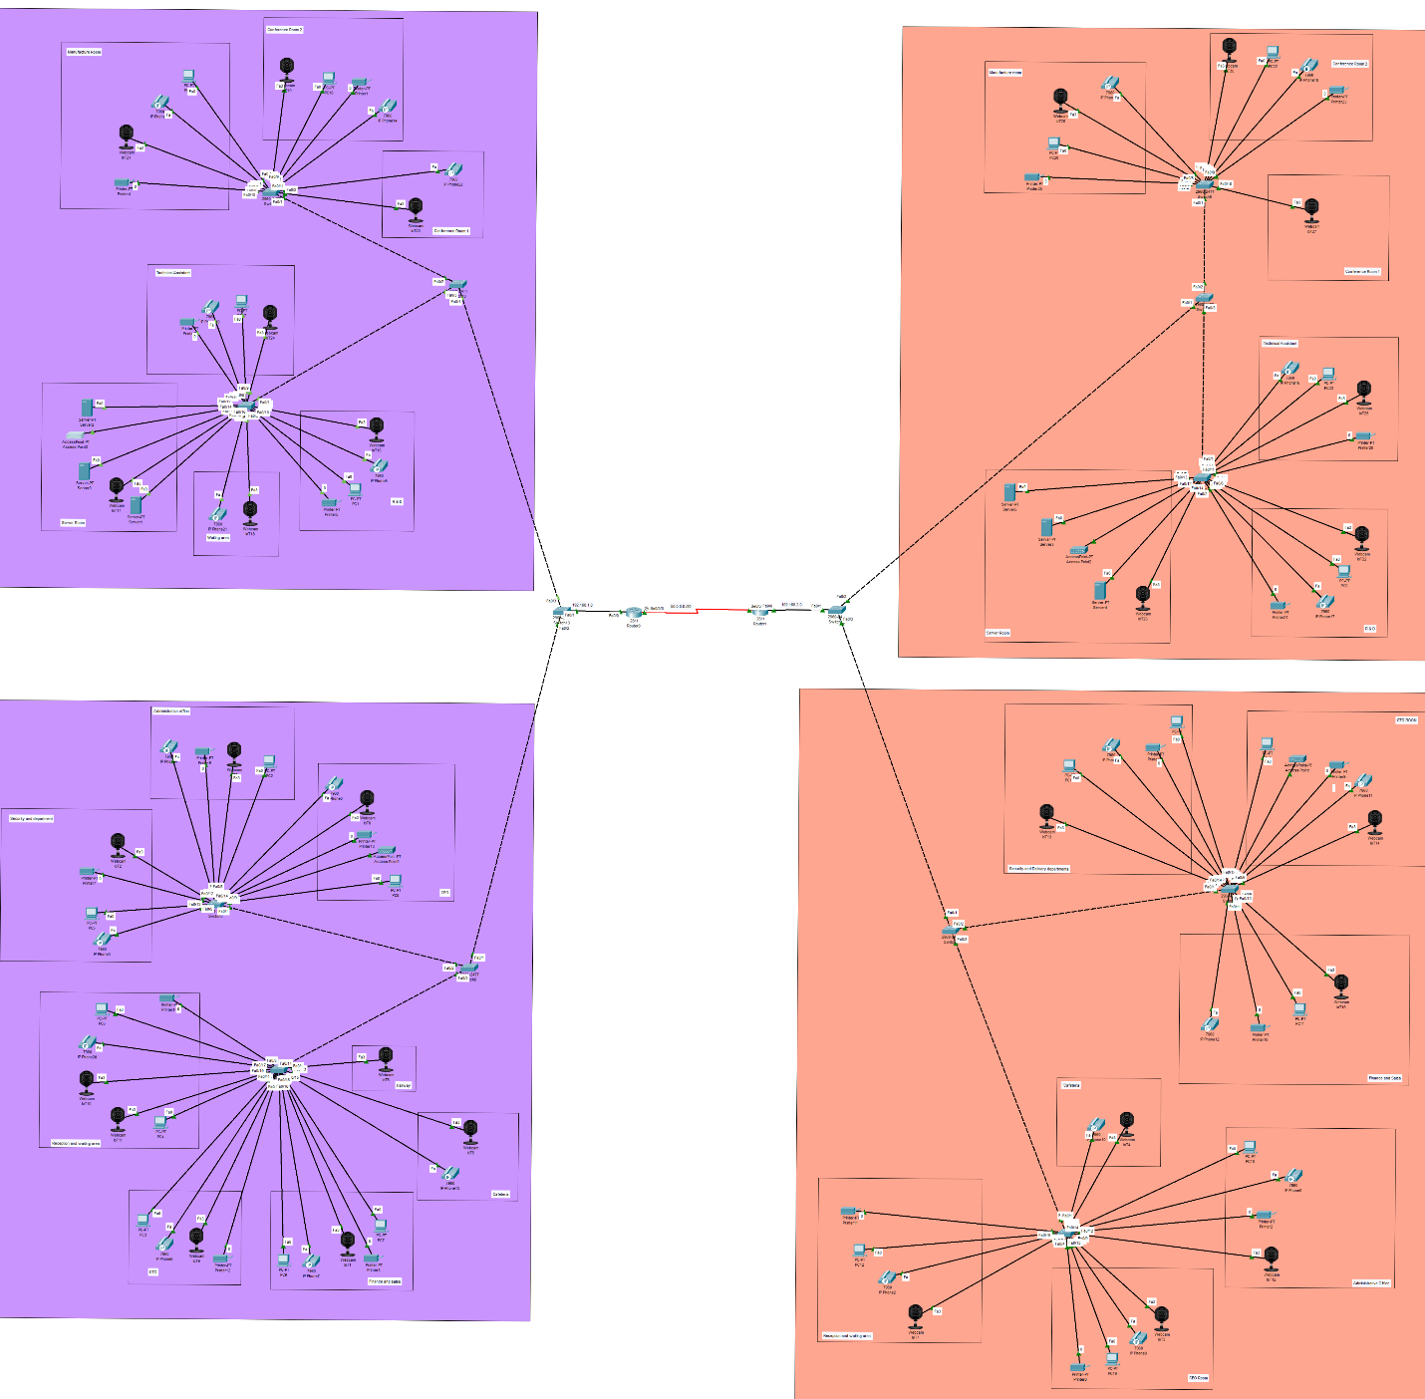

Fig: network diagram

The above network diagram illustrates about the computer telecommunication through the network system. It represents the many different purposes of networks such as to manage the networks between a large field like industries or companies. The network diagram also shows the distribution of the ip address throughout the field which diversely helps in the tracing of telecommunication. The above network diagram is designed with the help of cisco packet tracer and as per the information, the network diagram is labelled with different rooms and the buildings and floors are labelled with different colours as shown in the figure above. Each building of the company has a single router and each floor has 3 switches. Altogether there are two routers, twelve switches being used.

In the head office building switch four and three are connected to the end devices on the ground floor which connects to switch nine. Switch nine connects to switch twelve which connects to the router present in the building.

Switch four, joins CEO room, administrative office Reception and waiting room and Cafeteria within a network. Whereas switch three, joins security and delivery room, CTO room and finance and sales room within a network.

­­In the first-floor switch seven joins end devices on service room, research and design room and technical assistance room. Switch six joins end devices on two conference halls and manufacturing room. Similarly, in first floor switch six and seven are connected to the end devices and connects to switch eleven. Switch eleven connects to switch 12 which connects to the only router in the building.

In branch office, Cyberjaya, switch one and zero joins the end devices on ground floor which is connected to switch eight. Switch eight is connected to switch thirteen which joins with the router0.

CEO room, administrative office, and security and delivery room are joined to switch zero. CTO room reception and waiting room with cafeteria and Finance and sales room are joined with switch one.

In the first floor two conferencing room with manufacturing room are joined to switch five. Technical assistant room, waiting area, R&D room, service room are joined to switch two.

# Second floor of branch office (Cyberjaya)

The network of the IOT, Servers, Printers and Access points are managed through the static protocols. The networks were manually assigned to the destination from the source.

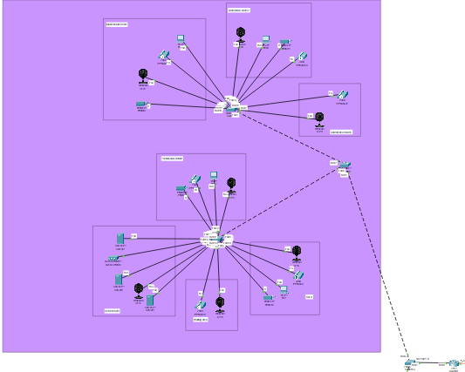

fig :second floor

# Static IP of webcam (IOT)

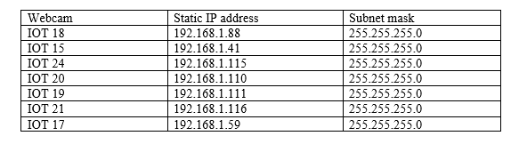

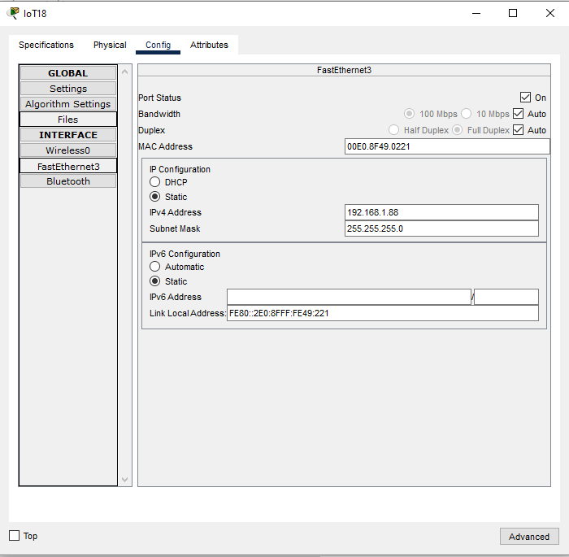

fig :IOT18

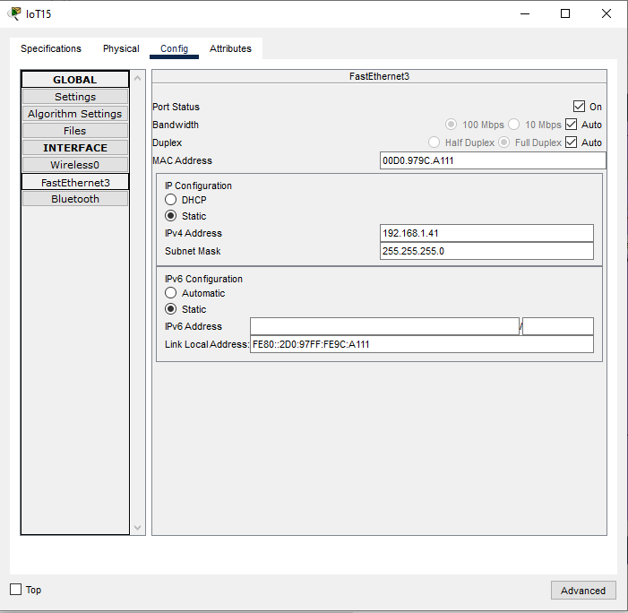

fig :IOT15

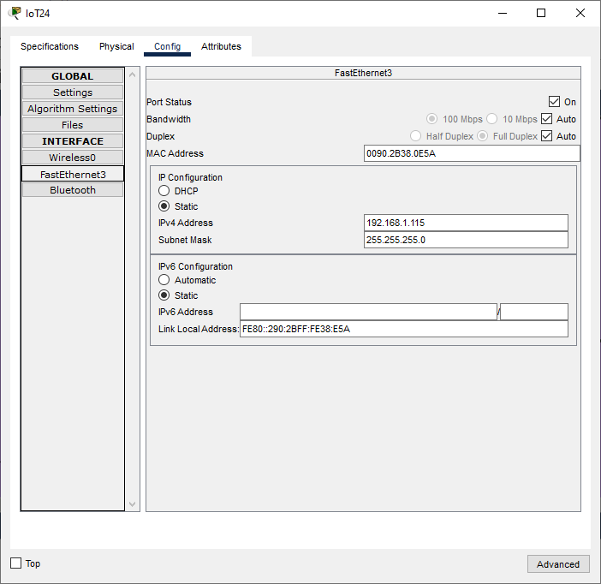  
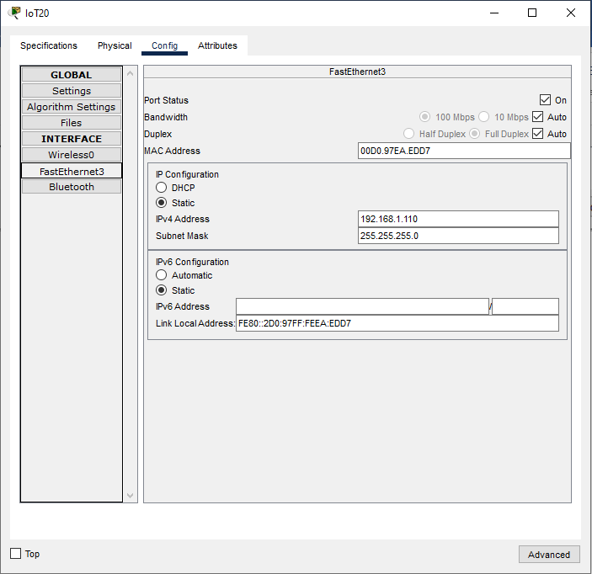

fig 15:IOT24

fig :IOT20

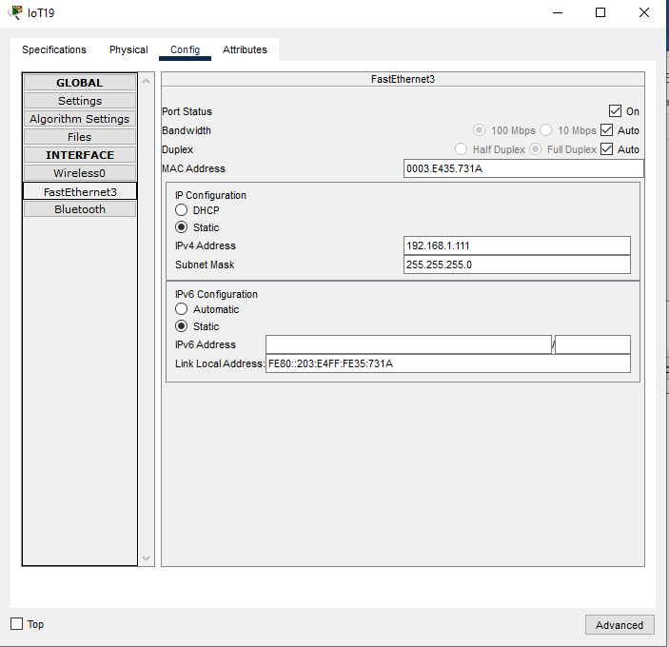

fig :IOT19

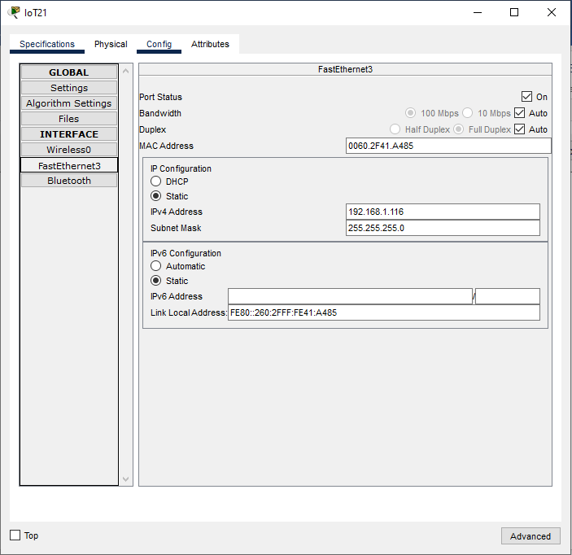

fig :IOT21

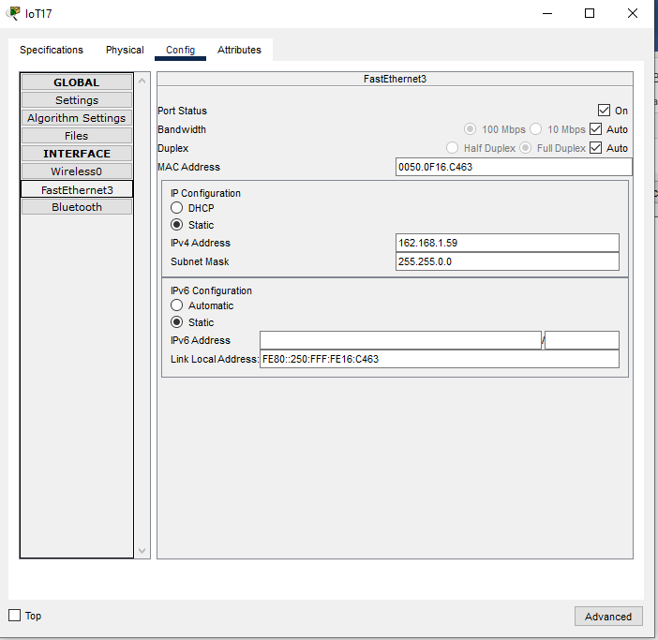

fig :IOT17

# Static IP of Servers

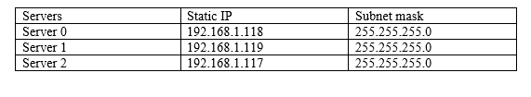

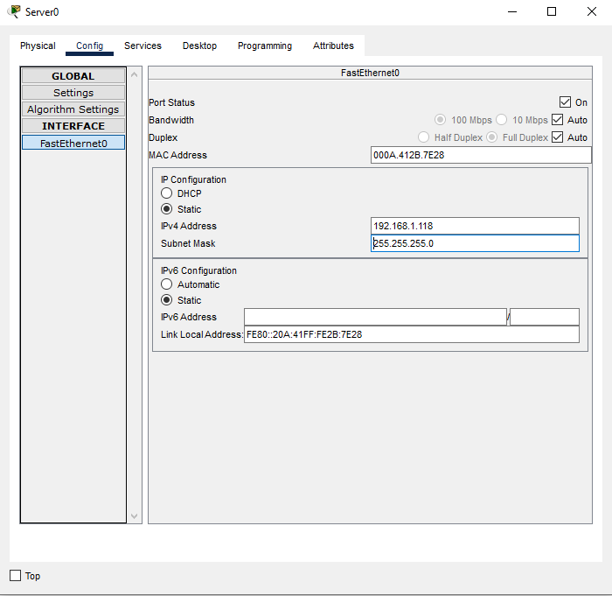

fig :Server0

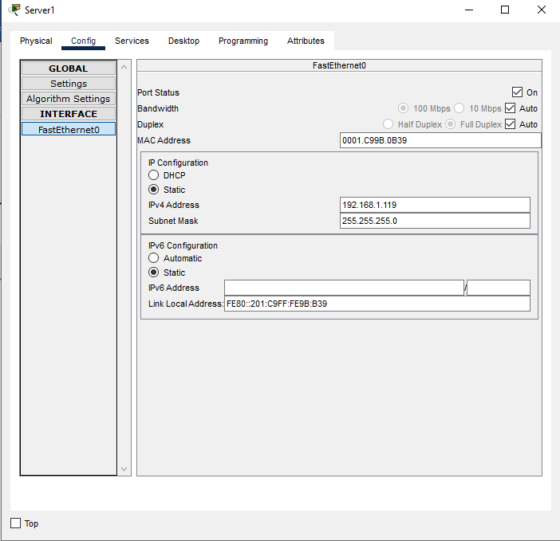

fig :Server1

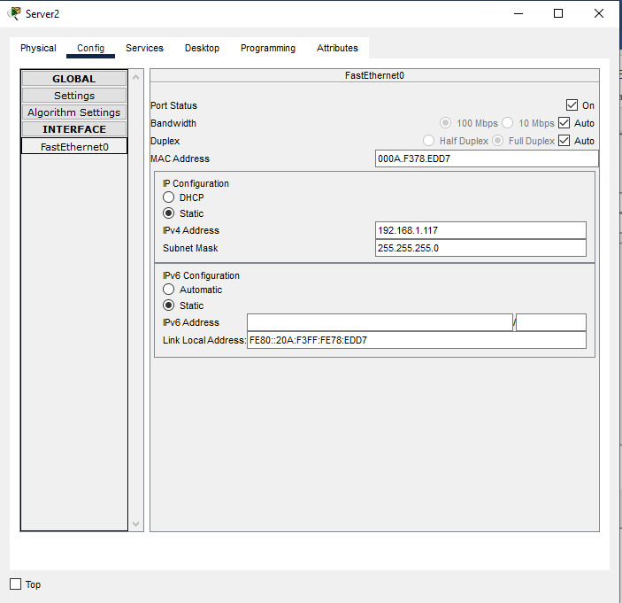

fig :Server2

# Static IP of Printer

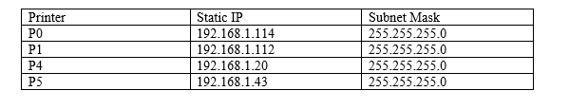

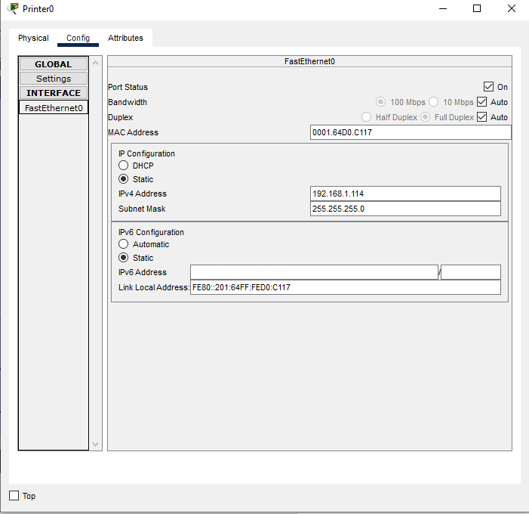

fig :printer0

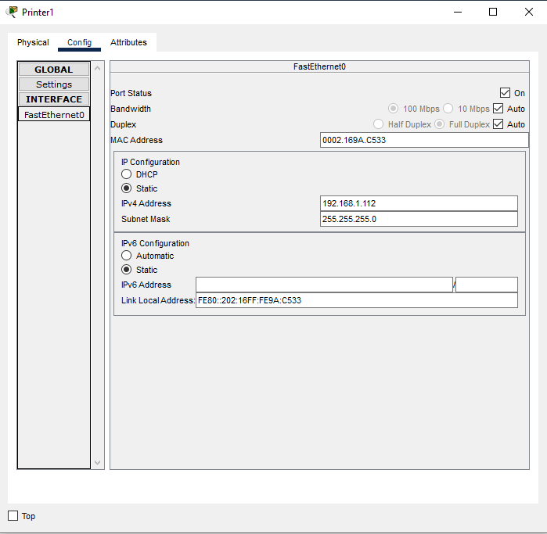

fig :Printer1

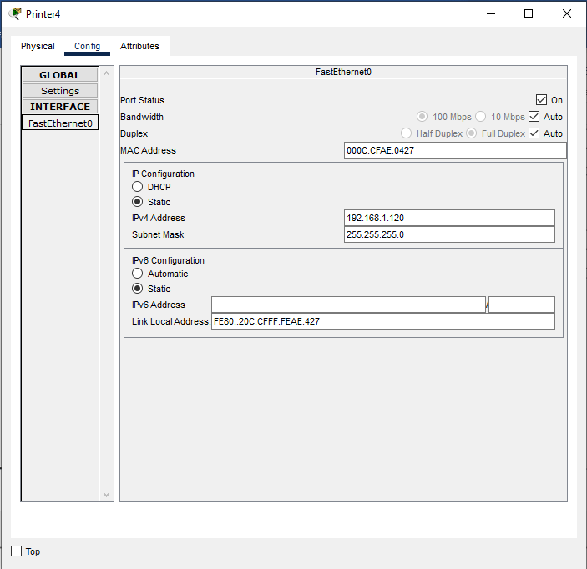

fig :Printer4

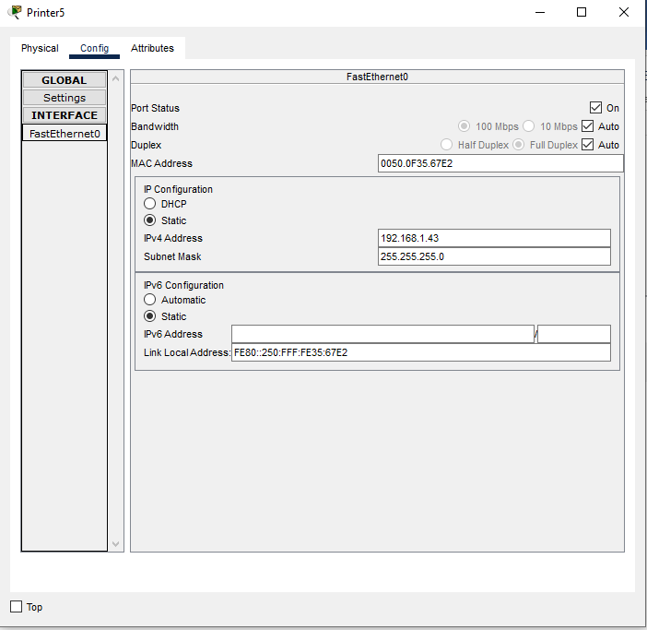

fig :Printer5

# Static IP of Access Point

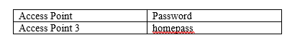

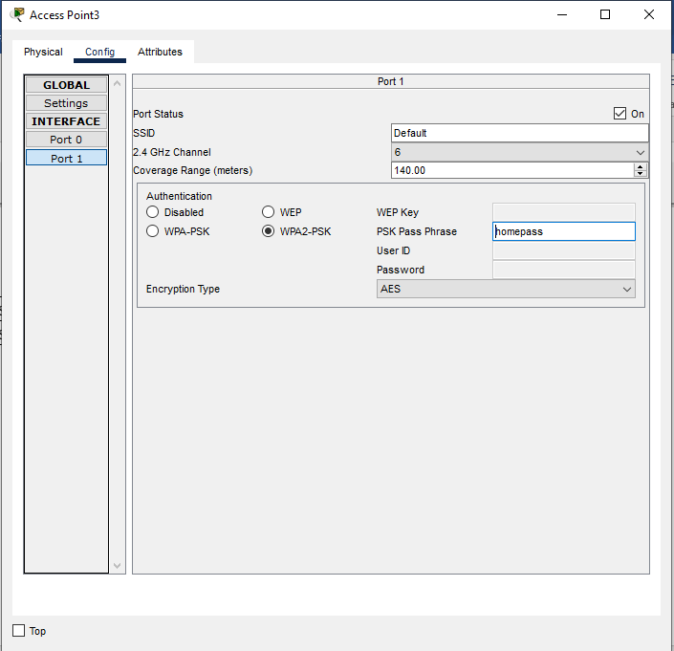

fig :Access point3

The networks of other PCs, Access points, Webcams, printers, and servers of other floors were managed through dhcp protocols.

# Dynamic Host Configuration Protocol (DHCP) [Safal Acharya NPI000170]:

It is the rule by which end devises connecting to the network are automatically assigned with the Ip- address, subnet mask, default gateway etc. DHCP servers are costly for organizations. Thus, router configuration is done to activate DHCP services. The client is provided with optional configuration parameters which describes about the availability of dhcp options. We did the dhcp configuration in our router1 and router2.

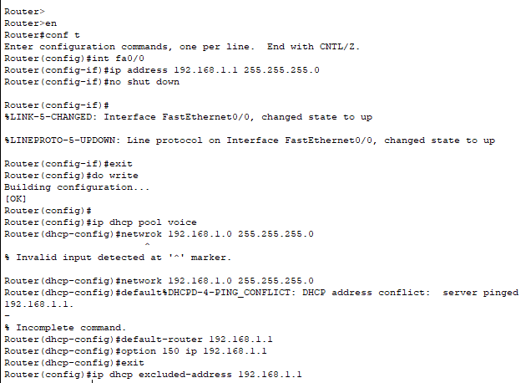

fig -dhcp configuration in router 1

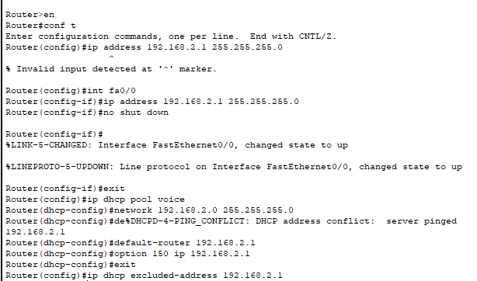

fig :dhcp configuration in router 2

# Cisco Telephony [Safal Acharya NPI000170]:

The VOIP phones are connected to the switch which is then directly connected to the router. Then the telephony configuration is done on the router and the IP phone is automatically assigned to the VOIP phone system.

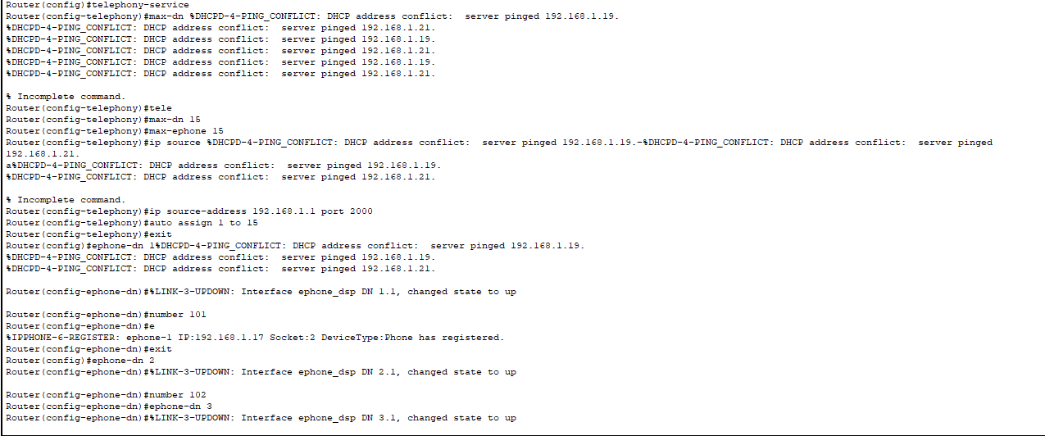

fig :telephony-service router1

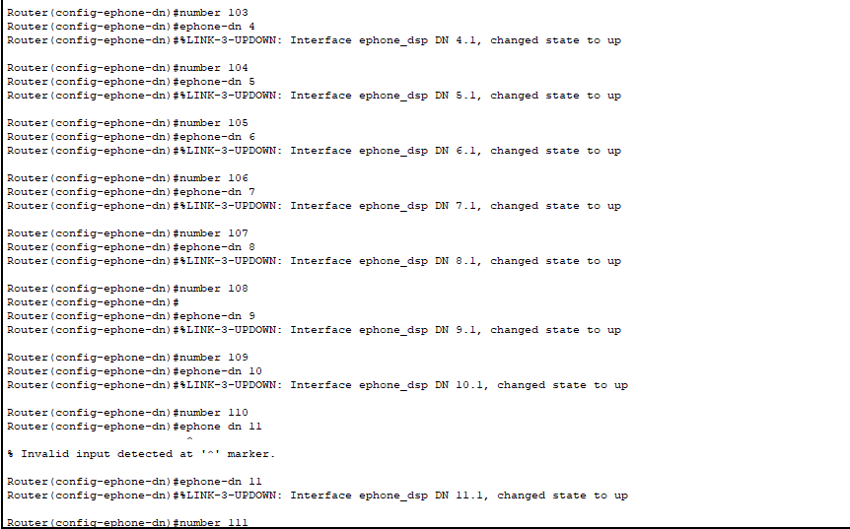

fig 30.1: telephony-service router 1

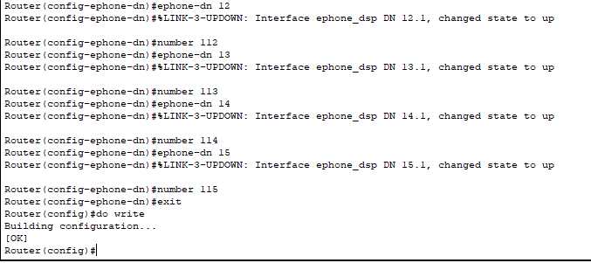

Fig 30.2: telephony-service router1

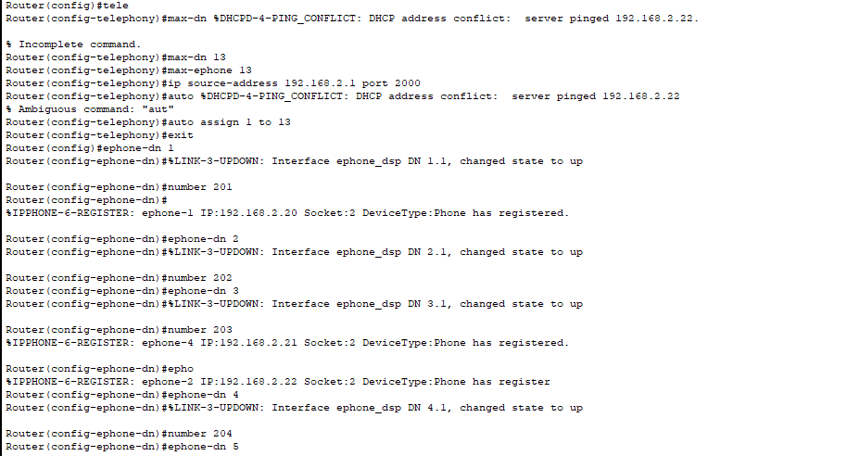

fig :telephony-service router2

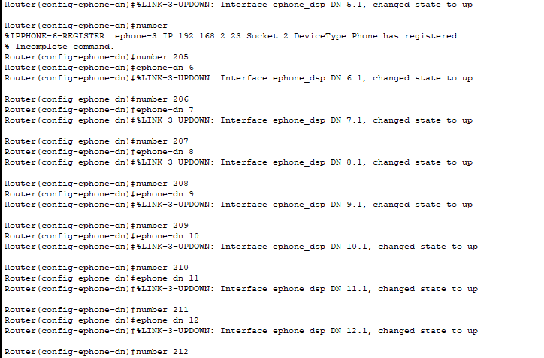

Fig 31.1: telephony-service router2

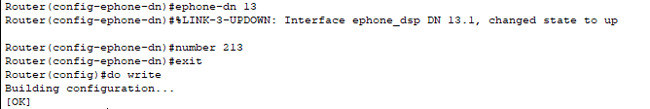

Fig 31.2: telephony-service router2

# Serial Configuration [Rangin Basnet NPI000167]:

The serial configuration is done on the routers because the serial configuration is slightly faster than the other configurations. We added clock rate and bandwidth in this configuration to manage the time between two frames and maintain the speed respectively.

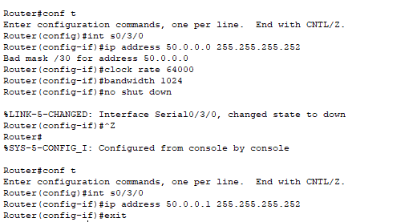

fig :serial configuration router1

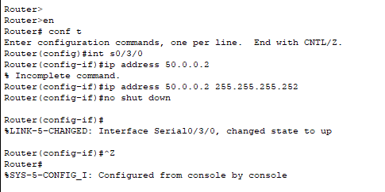

fig :serial configuration router2

# Router RIP configuration [Riden Paudel NPI000168]:

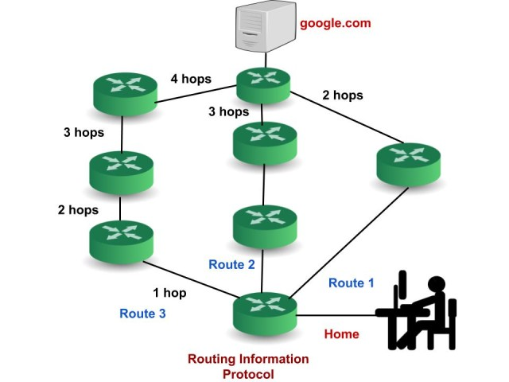

Selected

path

It is a simultaneous routing protocol. In OSI model it performs its task on network layer. It helps to find the shortest way between the source and the destination network. It is easy to configure and is not complicated. Its system of measurement is based on trip count basis which is maximum 15. It is not suitable for very large-scale organization or network because it is not scalable.

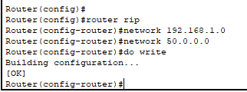

fig :router1 rip configuration

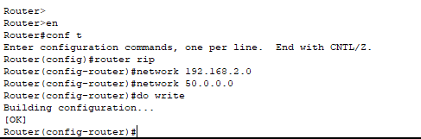

fig :router2 rip configuration

# Dial Peer Configuration [Sajag Shrestha NPI000172]

Dial Peer Configuration is the gate way for processing any sort of dial plans and providing voice services over an IP packet network. Call source and destination endpoints are identified by using dial peers, it is also used for defining the characteristics applied to each call leg in call connection. Dial peers are considered a crucial component of VoIP.

For configuring VoIP dial peer, you must identify the dial peer by appointing it a unique tag number, defining its designated telephone number and its destination IP address.

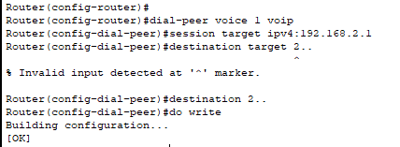

fig :dial-peer conf router1

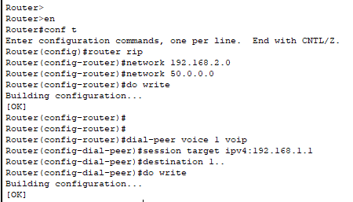

fig 37:dial-peer conf router2

# Switchport Voice VLAN [Sajag Shrestha NPI000172]

A voice VLAN is particularly assigned for voice data stream. It focusses to ensures the quality of voice traffic. The priority is always given to voice service although other data forms like video can transfer simultaneously. Source address of received voice packets and VLAN tags of the received packets are used to distinguish voice data streams.

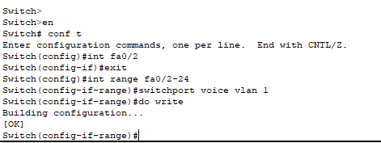

fig :switch port configuration

# *Referencing:*

*Sikkim Manipal University, Spring 2009,Computer Networks.*

*Network Fundamentals https://www.youtube.com/c/NetworkDirection*

*https://networkdirection.net/*

*Stallings, W. (1994), Data and Computer Communications, Fourth Edition,*

*Stallings, W. (1993), Local and Metropolitan Area Networks, Fourth Edition,  
Macmillan, NY.*

*Stallings, W. (1993b) Networking Standards: A Guide to OSI, ISDN, LAN, and  
MAN Standards, Addison-Wesley, Reading, MA.*

*Stamper, D. (1993), Local Area Networks, Addison-Wesley, Reading, MA.*

*Tanenbaum, A. (1989), Computer Networks, Second Edition, Prentice Hall,  
Englewood Cliffs, NJ.*

*Van Duuren, J., Schoute, F., and Kastelein, P. (1992) Telecommunications  
Networks and Services, Addison-Wesley, Reading, MA.*

*Viniotis Y. and Onvural R. (editors) (1993) Asynchronous Transfer Mode  
Networks, Plenum, New York, NY.*

*White, G. (1992) Internetworking and Addressing, McGraw-Hill, NY.*

*Zitsen, W. (1990) ‘Metropolitan Area Networks: Taking LANs into the Public  
Network,’ Telecommunications.*